Q1 swapping two nos

#include <stdio.h>

void swap(int *a, int *b) {

int temp = *a;

*a = *b;

*b = temp;

}

int main()

{

int num1, num2;

printf("Enter the first number: ");

scanf("%d", &num1);

printf("Enter the second number: ");

scanf("%d", &num2);

printf("Before swapping: num1 = %d, num2 = %d\n", num1, num2);

swap(&num1, &num2);

printf("After swapping: num1 = %d, num2 = %d\n", num1, num2);

return 0;

}

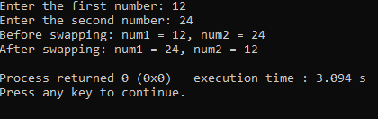

Q2 dynamic memory allocation

#include <stdio.h>

#include <stdlib.h>

void* Malloc(size_t size) {

return malloc(size);

}

void* Realloc(void* ptr, size_t size) {

return realloc(ptr, size);

}

void* Calloc(size_t num, size_t size) {

return calloc(num, size);

}

void Free(void* ptr) {

free(ptr);

}

int main() {

int *arr1, *arr2;

size_t size;

printf("Enter the size of the array: ");

scanf("%zu", &size);

arr1 = (int*)Malloc(size * sizeof(int));

if (arr1 == NULL) {

printf("Memory allocation failed.\n");

return 1;

}

printf("Enter elements of the array:\n");

for (size_t i = 0; i < size; i++) {

printf("Element %zu: ", i + 1);

scanf("%d", &arr1[i]);

}

printf("Elements of the array (malloc):\n");

for (size_t i = 0; i < size; i++) {

printf("%d ", arr1[i]);

}

printf("\n");

size *= 2;

arr2 = (int*)Realloc(arr1, size * sizeof(int));

if (arr2 == NULL) {

printf("Memory reallocation failed.\n");

Free(arr1);

return 1;

}

printf("Enter additional elements of the array:\n");

for (size_t i = size / 2; i < size; i++) {

printf("Element %zu: ", i + 1);

scanf("%d", &arr2[i]);

}

printf("Elements of the array (realloc):\n");

for (size_t i = 0; i < size; i++) {

printf("%d ", arr2[i]);

}

printf("\n");

Free(arr2);

return 0;

}

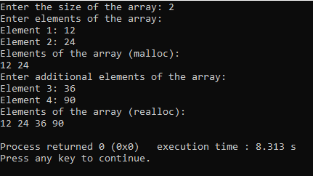

Q3 stack implementation

#include <stdio.h>  
#include <stdlib.h>  
#define MAX_SIZE 10  
  
  
struct Stack {  
    int items[MAX_SIZE];  
    int top;  
};  
  
  
void initialize(struct Stack *stack) {  
    stack->top = -1; // Set top to -1 to indicate an empty stack  
}  
  
  
int isEmpty(struct Stack *stack) {  
    return stack->top == -1;  
}  
  
  
int isFull(struct Stack *stack) {  
    return stack->top == MAX_SIZE - 1;  
}  
  
  
void push(struct Stack *stack, int value) {  
    if (isFull(stack)) {  
        printf("Stack overflow. Cannot push %d.\n", value);  
    } else {  
        stack->top++;  
        stack->items[stack->top] = value;  
        printf("Pushed %d onto the stack.\n", value);  
    }  
}  
  
  
int pop(struct Stack *stack) {  
    int poppedValue = -1; // Default value for an empty stack  
  
    if (isEmpty(stack)) {  
        printf("Stack underflow. Cannot pop from an empty stack.\n");  
    } else {  
        poppedValue = stack->items[stack->top];  
        stack->top--;  
        printf("Popped %d from the stack.\n", poppedValue);  
    }  
  
    return poppedValue;  
}  
  
  
void display(struct Stack *stack) {  
    if (isEmpty(stack)) {  
        printf("Stack is empty.\n");  
    } else {  
        printf("Elements in the stack: ");  
        for (int i = 0; i <= stack->top; i++) {  
            printf("%d ", stack->items[i]);  
        }  
        printf("\n");  
    }  
}  
  
int main() {  
    struct Stack stack;  
    initialize(&stack);  
  
    push(&stack, 10);  
    push(&stack, 20);  
    push(&stack, 30);  
    display(&stack);  
  
    pop(&stack);  
    display(&stack);  
  
    push(&stack, 40);  
    display(&stack);  
  
    return 0;  
}

